IPM Farmers dimensionality and clustering report

8/6/2021

Prepared by: Martin Marzidovšek

Dataset: [Farmers_edited data 21.12.2020_IPS_FINAL- WEKA_JM.xlsx](https://kt-cloud.ijs.si/index.php/f/199967)

# Question 1 - Already_used_DSS

# Dimensionality reduction [with Region attributes]

Attributes: ['Age_Cat', 'Gender_1male', 'Degree_Cat', 'Farm_size_Cat', 'Income_Cat',

'Legislative_requirements', 'Computer_at_home', 'Speed_internet_Cat',

'Already_used_DSS', 'Willing_to_try_new_products_Cat',

'Price_important_factor', 'Importance_of_easy_to_use_1to3',

'Importance_of_efficient_1to3', 'Importance_low_price_1to3',

'Importance_polyvalence_1to3', 'Enjoy_using_new_techs_1to3',

'Appreciate_change_1to3', 'Trust_in_DSS_1to3', 'Need_IT_teaching_Cat',

'DSS_can_improve_your_productivity_Cat', 'WTP_for_DSS_Cat',

'DSS_must_be_tailored_for_your_farm_Cat',

'Manufacturer_demo_of_DSS_Cat', **'Region_central_EU', 'Region_north_EU',**

**'Region_south_EU**']

### 2D projeciton of ordinal and numeric features

Odinal attributes: 'Age_Cat', 'Degree_Cat', 'Farm_size_Cat', 'Income_Cat',

'Speed_internet_Cat', 'Importance_of_easy_to_use_1to3',

'Importance_of_efficient_1to3', 'Importance_low_price_1to3',

'Importance_polyvalence_1to3', 'Enjoy_using_new_techs_1to3',

'Appreciate_change_1to3', 'Trust_in_DSS_1to3', 'Need_IT_teaching_Cat',

'DSS_can_improve_your_productivity_Cat', 'WTP_for_DSS_Cat',

'DSS_must_be_tailored_for_your_farm_Cat',

'Manufacturer_demo_of_DSS_Cat', 'Willing_to_try_new_products_Cat'

picture:

* Numbers represent index of instancses
* Colors=«DSS_can_improve_your_productivity_Cat«

Comment:

* Projection in 2D show disperesed data wtih no clear clusters

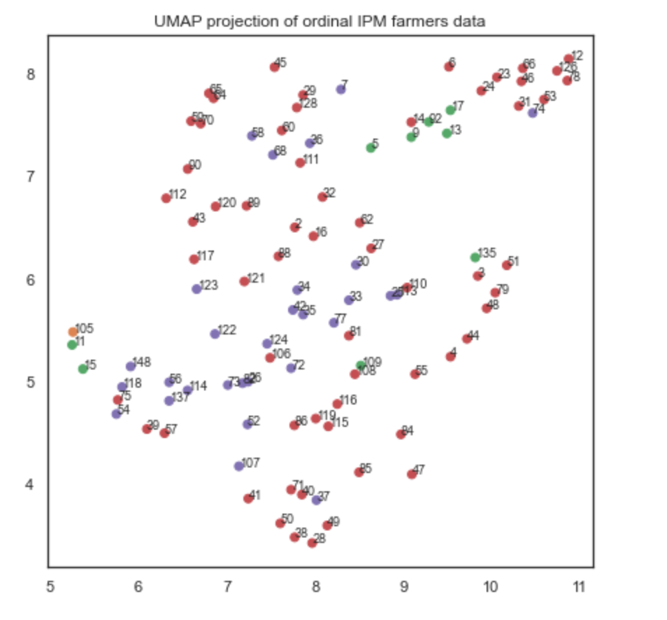

### 2D projeciton of nominal features

Nominal attributes: 'Gender_1male', 'Legislative_requirements', 'Computer_at_home',

'Already_used_DSS', 'Price_important_factor', 'Region_central_EU',

'Region_north_EU', 'Region_south_EU'

Picture:

* Numbers represent index of instancses
* Colors:
  + Orange=1
  + Blue=0

Comment:

* Projection in 2D shows 3 clear clusters, which are prettly clearly devided in respect to attributes relating to region.

### 

### 2D projeciton of Union of nominal and ordinal features

Picture:

* Numbers represent index of instancses
* Colors:
  + Orange=1
  + Blue=0

Comment:

* Projection of union of ordinal and nominal dim reducitons in 2D still points to 3 clusters, seems influenced by region attributes.

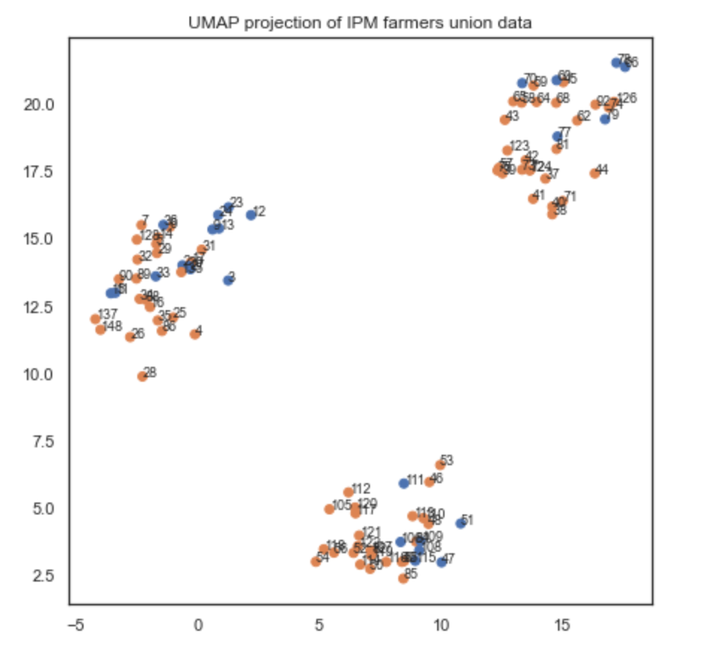

# Dimensionality reduction [without Region attributes]

Attributes: ['Age_Cat', 'Gender_1male', 'Degree_Cat', 'Farm_size_Cat', 'Income_Cat',

'Legislative_requirements', 'Computer_at_home', 'Speed_internet_Cat',

'Already_used_DSS', 'Willing_to_try_new_products_Cat',

'Price_important_factor', 'Importance_of_easy_to_use_1to3',

'Importance_of_efficient_1to3', 'Importance_low_price_1to3',

'Importance_polyvalence_1to3', 'Enjoy_using_new_techs_1to3',

'Appreciate_change_1to3', 'Trust_in_DSS_1to3', 'Need_IT_teaching_Cat',

'DSS_can_improve_your_productivity_Cat', 'WTP_for_DSS_Cat',

'DSS_must_be_tailored_for_your_farm_Cat',

'Manufacturer_demo_of_DSS_Cat', ~~'Region_central_EU', 'Region_north_EU',~~

~~'Region_south_EU'~~]

### 2D projeciton of ordinal and numeric features

Odinal attributes: 'Age_Cat', 'Degree_Cat', 'Farm_size_Cat', 'Income_Cat',

'Speed_internet_Cat', 'Importance_of_easy_to_use_1to3',

'Importance_of_efficient_1to3', 'Importance_low_price_1to3',

'Importance_polyvalence_1to3', 'Enjoy_using_new_techs_1to3',

'Appreciate_change_1to3', 'Trust_in_DSS_1to3', 'Need_IT_teaching_Cat',

'DSS_can_improve_your_productivity_Cat', 'WTP_for_DSS_Cat',

'DSS_must_be_tailored_for_your_farm_Cat',

'Manufacturer_demo_of_DSS_Cat', 'Willing_to_try_new_products_Cat'

picture:

* Numbers represent index of instancses
* Color=«DSS_can_improve_your_productivity_Cat«

Comment:

* Projection in 2D show disperesed data wtih no clear clusters

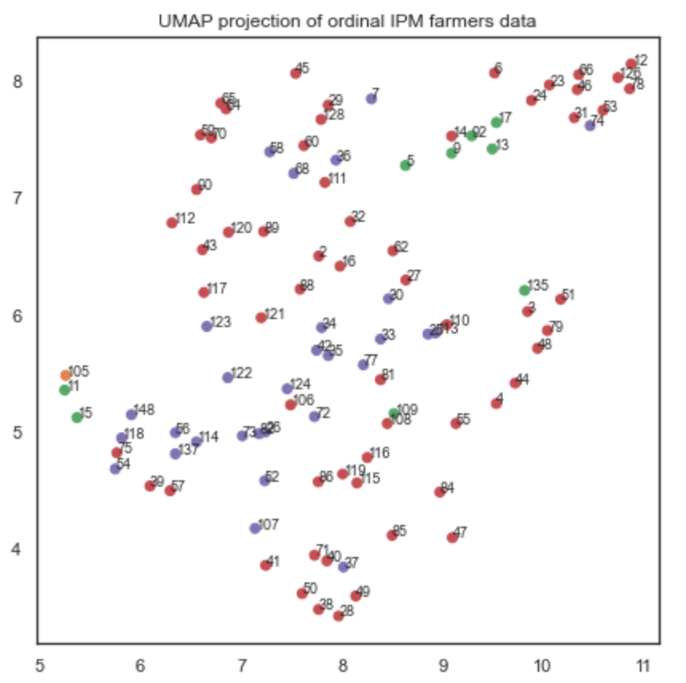

### 2D projeciton of nominal features

Nominal attributes: 'Gender_1male', 'Legislative_requirements', 'Computer_at_home',

'Already_used_DSS', 'Price_important_factor', ~~'Region_central_EU',~~

~~'Region_north_EU', 'Region_south_EU'~~

Picture:

* Numbers represent index of instancses
* Colors:
  + Orange=1
  + Blue=0

Comment:

* Projection in 2D shows 2 clear clusters, which are prettly clearly devided in respect to attribute »Already_used_DSS«.
* 3 instnaces (index: 78, 47, 79) are outliers as they are positioned in the other cluster as they maj-ority of instance with the same value. (instances in blue); Would be worthwhile to check what is different about them; perhaps try to model and see how they are classified.

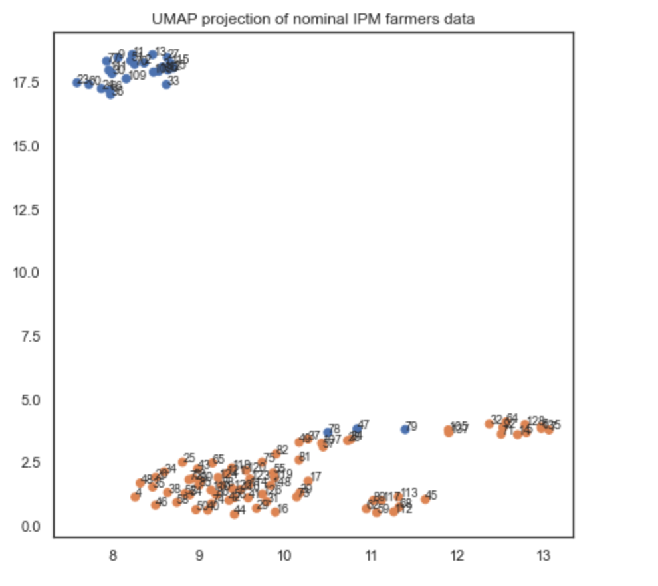

### 2D projeciton of Union of nominal and ordinal features

Picture:

* Numbers represent index of instancses
* Colors:
  + Orange=1
  + Blue=0

Comment:

* Projection of union of ordinal and nominal dim reducitons in 2D still points to »2 clusters«, which are clearly separated in respect to attribute »Already_used_DSS«.
* Again, 3 instnaces (index: 78, 47, 79) are outliers as before (see above)

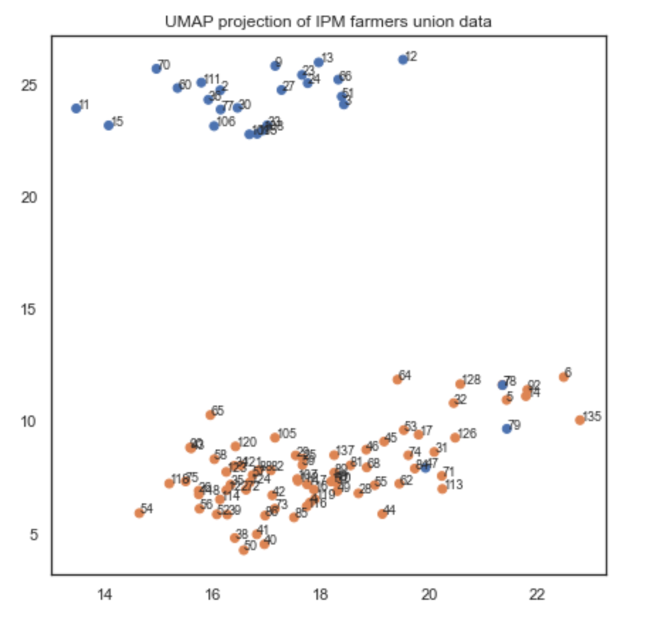

# Clustering [without region attributes]

## HDBSCAN clustering

Picture:

* Numbers/colors represent clusters

Comment:

* Projection of union of ordinal and nominal dim reducitons in 2D still points to »2 clusters«, which are clearly separated in respect to attribute »Already_used_DSS«.

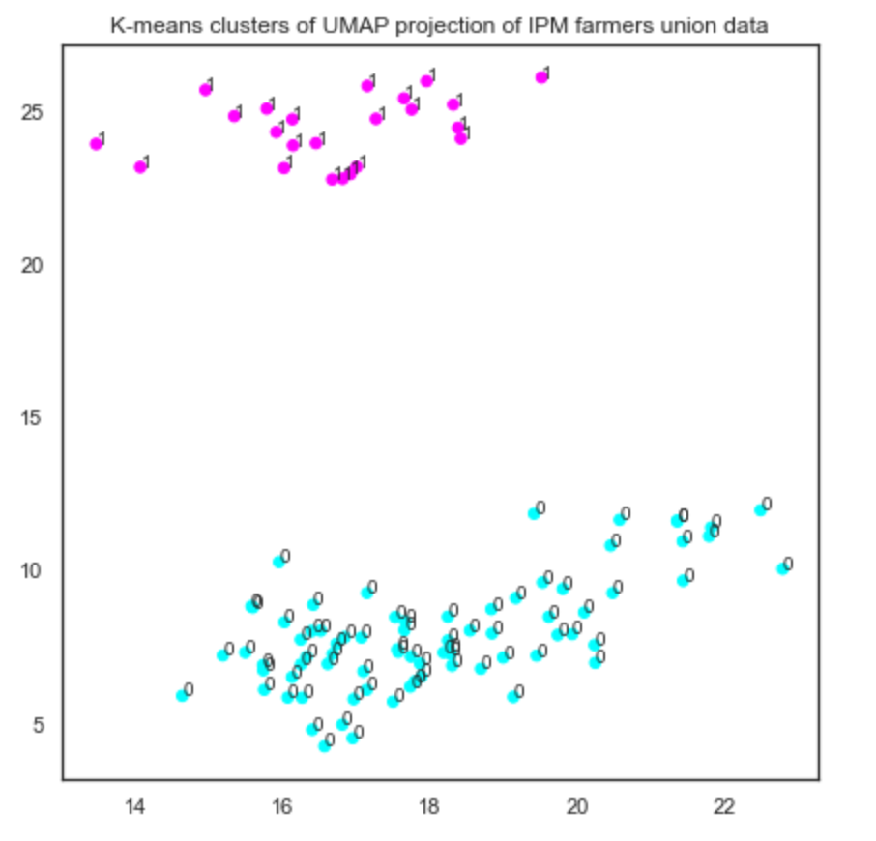

Clusters: [0, 0, 1, 1, 1, 1, 0, 0, 0, 0, 1, 0, 1, 1, 0, 0, 1, 1, 0, 1, 1, 0,

1, 1, 0, 1, 1, 0, 1, 1, 1, 1, 1, 1, 1, 1, 1, 1, 1, 1, 1, 1, 0, 1,

1, 1, 1, 1, 1, 1, 1, 0, 1, 1, 1, 0, 1, 0, 1, 1, 1, 1, 1, 0, 1, 1,

1, 1, 1, 1, 1, 1, 1, 1, 1, 1, 0, 1, 0, 0, 1, 0, 1, 1, 1, 0, 1, 1,

1, 1, 1, 1, 1, 1, 1, 1, 1, 1, 1, 1]

For modelling see CSV file (includes clusters): »IPM_farmers-data_clusters_question1.csv«